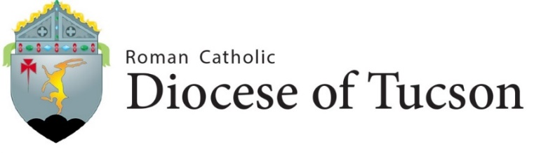

INDIVIDUAL AFFIRMATION
Date:

Memorandum to: Most Reverend Edward J. Weisenburger
Bishop of Tucson

Reference: Diocese of Tucson Code of Conduct and Guidelines for the Prevention of and Response to Sexual Misconduct

Subject: ATTESTATION/ AFFIRMATION

As a(n) in , I am
(Employee or volunteer) (Name of parish or organization)
committed to joining the members of our Catholic community in our common commitment to protect our children, adolescents, and vulnerable adults.

I hereby attest/affirm that I have read, understand and agree to adhere to the policies and procedures of the Diocese of Tucson as articulated in the Code of Conduct, and the Summary Statement of the Guidelines for the Prevention of and Response to Sexual Misconduct in support of that common commitment.

Attested/ Affirmed to:

Print Name Title

_________________________________ _________________________________
Signature Ministry/Ministries

Witnessed by:

Name Title

